**Programming Fundamentals**

**C++2D-Array-Exercises**

This repository contains beginner-level C++ programs created as part of Programming Fundamentals coursework. Topics include 1D and 2D arrays, element replacement, sum calculation, finding maximum values, and table formatting using nested loops**.**

# Statement no 1:

Design a C++ program that engages the user in inputting values into an array of 10 integers. Additionally, prompt the user to provide an integer value V for replacement and an index value i, ensuring it falls within the range of 0 to 9. Subsequently, the program should replace the value at index i with V and display the updated array.

# Program:

#include<iostream> using namespace std; int main () {

int array [10];

cout<<"Enter the integer value you want to store:"<<endl; for (int i=0; i<10; ++i) {

cout<<"Enter the value of index "<<i<<":"; cin>>array[i];

}

int repvalue, index;

cout<<"Enter the replacement value:"; cin>>repvalue;

cout<<"Enter the index (0 to 9) for replacement:"; cin>>index;

do { array[index]=repvalue;

}

while (index<0||index>=10); cout<<"\nUpdated array: "; for (int i=0; i<10; ++i) { cout<<array[i]<<" ";

}

return 0;

}

# Output:

**Statement no 2:**

Simulate a program in C++ that utilizes a 3x3 array to store user-input numbers. The program should prompt the user to enter values for each element in the array. After populating the array, calculate and display the sum of all elements in the array. Implement the program with appropriate loops for rows and columns.

**Program:** #include<iostream> using namespace std; int main () {

int arr [3][3];

cout<<"Enter the value for Array:"<<endl; for (int r=0; r<3; r++) {

for (int c=0; c<3; c++) { cin>>arr[r][c];

}

}

int sum=0;

for (int r=0; r<3; r++) { for (int c=0; c<3; c++) { sum+=arr[r][c];

}

}

cout<<"The Sum of Array Elements:"<<sum<<endl; return 0;

}

# Output:

**Statement no 3:**

Develop a C++ program that involves user input for a 2D array with dimension 4x4. The program should prompt the user to input data into each element of the array and then determine the maximum value present. Implement nested loops to collect user input efficiently and find the maximum value within the array. Additionally, evaluate the program's structure, ensuring it effectively calculates and displays the maximum value.

**Program:** #include<iostream> using namespace std; int main () {

int arr [4][4];

cout<<"Enter the elements for 4x4 Array:"<<endl; for (int r=0; r<4; r++) {

for (int c=0; c<4; c++) { cin>>arr[r][c];

}

}

int maxvalue=arr [0][0]; for (int r=0; r<4; r++) { for (int c=0; c<4; c++)

{

if(arr[r][c]>maxvalue) maxvalue=arr[r][c];

}

}

cout<<"the Maximum value in the array is:"<<maxvalue<<endl; return 0;}

# Output:

**Statement no 4:**

Develop a C++ program that utilizes a 2D array named "table" to store predefined values. The program should display the contents of the table in a tabular format. It prints the data from the table in tabular form, utilizing the <iomanip> header for formatting. Demonstrate an understanding of array initialization and nested loops for traversing the array elements.

# Program:

#include <iostream> #include <iomanip> using namespace std; int main () {

int table [3][4] = {{1, 2, 3, 4}, {5, 6, 7, 8}, {9, 10, 11, 12}};

cout << " The Vales of 2D array in the form of Table:" << endl; for (int i = 0; i < 3; ++i) {

for (int j = 0; j < 4; ++j) { cout << setw(5) << table[i][j];

}

cout << endl;

}

return 0;}

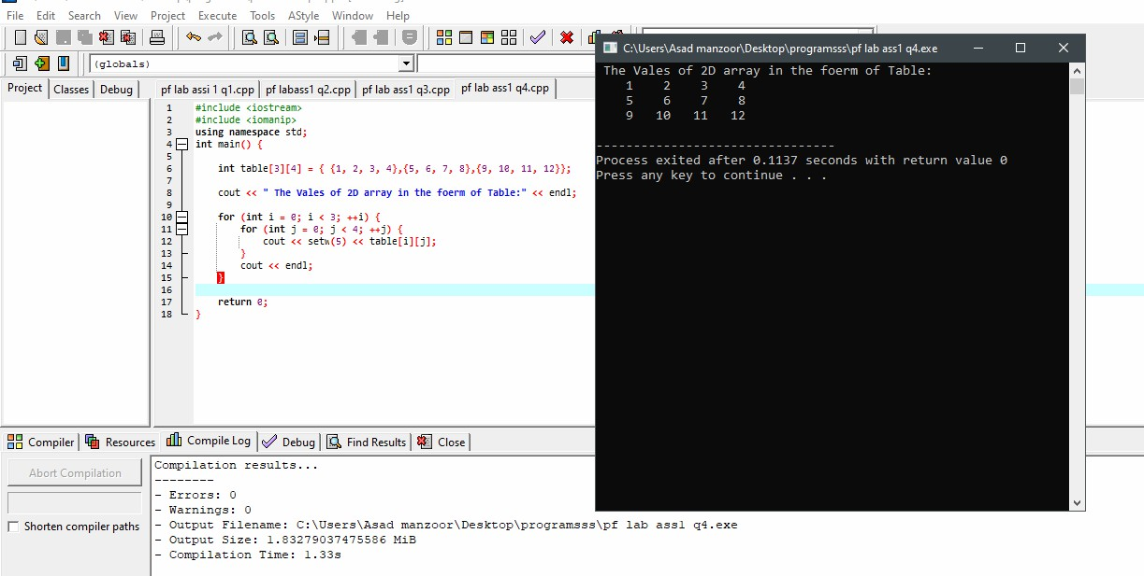**Output:**